Project code

import pandas as pd

import numpy as np

import matplotlib.pyplot as plt

import seaborn as sns

# Set aesthetics for plots

sns.set_theme(style="whitegrid", palette="muted")

plt.rcParams.update({'figure.autolayout': True})

# Load the dataset

file_path = r"C:\Users\USER\Downloads\realtime_data.csv"

df = pd.read_csv(file_path)

# -------------------------

# 1. DATA CLEANING & VISUALIZATION

# -------------------------

# Check for missing values

print("Missing values per column:\n", df.isnull().sum())

# Convert date

df['lastUpdated'] = pd.to_datetime(df['lastUpdated'], format='%d-%m-%Y', errors='coerce')

# Drop duplicates

df = df.drop_duplicates()

# Total beneficiaries by state

state_beneficiaries = df.groupby('state_name')['total_beneficiaries'].sum().reset_index().sort_values(by='total_beneficiaries', ascending=False)

# Bar plot - Total Beneficiaries by State

plt.figure(figsize=(14, 6))

#sns.barplot(data=state_beneficiaries, x='state_name', y='total_beneficiaries', palette='Spectral', dodge=False)

sns.barplot(data=state_beneficiaries, x='state_name', y='total_beneficiaries', hue='state_name', palette='Spectral', dodge=False, legend=False)

plt.xticks(rotation=90)

plt.title("Total Beneficiaries by State")

plt.xlabel("State")

plt.ylabel("Total Beneficiaries")

plt.tight_layout()

plt.show()

# -------------------------

# 2. EDA & STATISTICAL ANALYSIS

# -------------------------

# Correlation Matrix Heatmap

plt.figure(figsize=(10, 7))

correlation = df[['total_beneficiaries', 'total_aadhar', 'total_mobileno', 'total_sc', 'total_st', 'total_gen', 'total_obc']].corr()

sns.heatmap(correlation, annot=True, cmap='coolwarm', linewidths=0.5)

plt.title("Correlation Heatmap")

plt.tight_layout()

plt.show()

# Scatterplot - Aadhaar vs Beneficiaries

plt.figure(figsize=(10, 6))

sns.scatterplot(data=df, x='total_aadhar', y='total_beneficiaries', hue='state_name', palette='tab20', alpha=0.7)

plt.title("Aadhaar Linked vs Total Beneficiaries")

plt.xlabel("Aadhaar Linked")

plt.ylabel("Total Beneficiaries")

plt.legend(loc='center left', bbox_to_anchor=(1, 0.5), fontsize='small')

plt.tight_layout()

plt.show()

# Correlation between aadhar and beneficiaries

cor_val = df['total_aadhar'].corr(df['total_beneficiaries'])

print(f"\nCorrelation between Total Aadhar and Total Beneficiaries: {cor_val}")

# -------------------------

# 3. CREATIVITY & INNOVATION

# -------------------------

# Inclusion Score = average of Aadhaar + Mobile coverage

df['inclusion_score'] = (df['total_aadhar'] + df['total_mobileno']) / (2 * df['total_beneficiaries'])

df['inclusion_score'] = df['inclusion_score'].clip(upper=1.0)

# Top 5 inclusive districts

top_districts = df.groupby('district_name')['inclusion_score'].mean().reset_index().sort_values(by='inclusion_score', ascending=False).head(5)

print("\nTop 5 Districts by Inclusion Score:\n", top_districts)

# Top 5 inclusive states

top_states = df.groupby('state_name')['inclusion_score'].mean().reset_index().sort_values(by='inclusion_score', ascending=False).head(5)

print("\nTop 5 States by Inclusion Score:\n", top_states)

# Plot top 5 states by Inclusion Score

'''plt.figure(figsize=(10, 5))

sns.barplot(data=top_states, x='state_name', y='inclusion_score', palette='coolwarm', dodge=False)

plt.title("Top 5 States by Inclusion Score")

plt.ylabel("Inclusion Score")

plt.xlabel("State")

plt.tight_layout()

plt.show()'''

# Trend in scheme reporting over time

monthly_report = df.copy()

monthly_report['month'] = monthly_report['lastUpdated'].dt.to_period('M')

monthly_trend = monthly_report.groupby('month').size().reset_index(name='report_count')

plt.figure(figsize=(10, 5))

sns.lineplot(data=monthly_trend, x='month', y='report_count', marker='o', color='purple')

plt.title("Monthly Scheme Data Reporting Trend")

plt.xlabel("Month")

plt.ylabel("Reports Count")

plt.xticks(rotation=45)

plt.tight_layout()

plt.show()

# District-wise beneficiary analysis (Top 20)

top_districts_beneficiaries = df.groupby('district_name')['total_beneficiaries'].sum().reset_index().sort_values(by='total_beneficiaries', ascending=False).head(20)

'''plt.figure(figsize=(12, 6))

sns.barplot(data=top_districts_beneficiaries, x='district_name', y='total_beneficiaries', palette='viridis')

plt.title("Top 20 Districts by Total Beneficiaries")

plt.xlabel("District")

plt.ylabel("Total Beneficiaries")

plt.xticks(rotation=45, ha='right')

plt.tight_layout()

plt.show()'''

plt.figure(figsize=(12, 6))

sns.barplot(data=top_districts_beneficiaries, x='district_name', y='total_beneficiaries', hue='district_name', palette='viridis', dodge=False, legend=False)

plt.title("Top 20 Districts by Total Beneficiaries")

plt.xlabel("District")

plt.ylabel("Total Beneficiaries")

plt.xticks(rotation=45, ha='right')

plt.tight_layout()

plt.show()

# -------------------------

# Optional: Save static plot as PDF

# -------------------------

plt.figure(figsize=(12, 6))

sns.boxplot(data=df[['total_beneficiaries', 'total_aadhar', 'total_mobileno']], palette='Set2')

plt.title("Boxplot for Key Metrics")

plt.tight_layout()

#plt.savefig("key_metrics_boxplot.pdf")

plt.show()

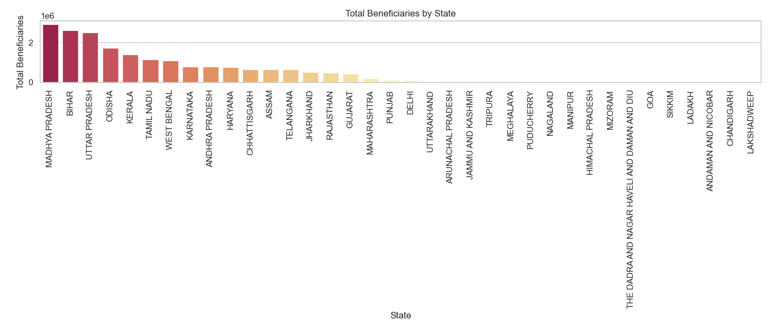

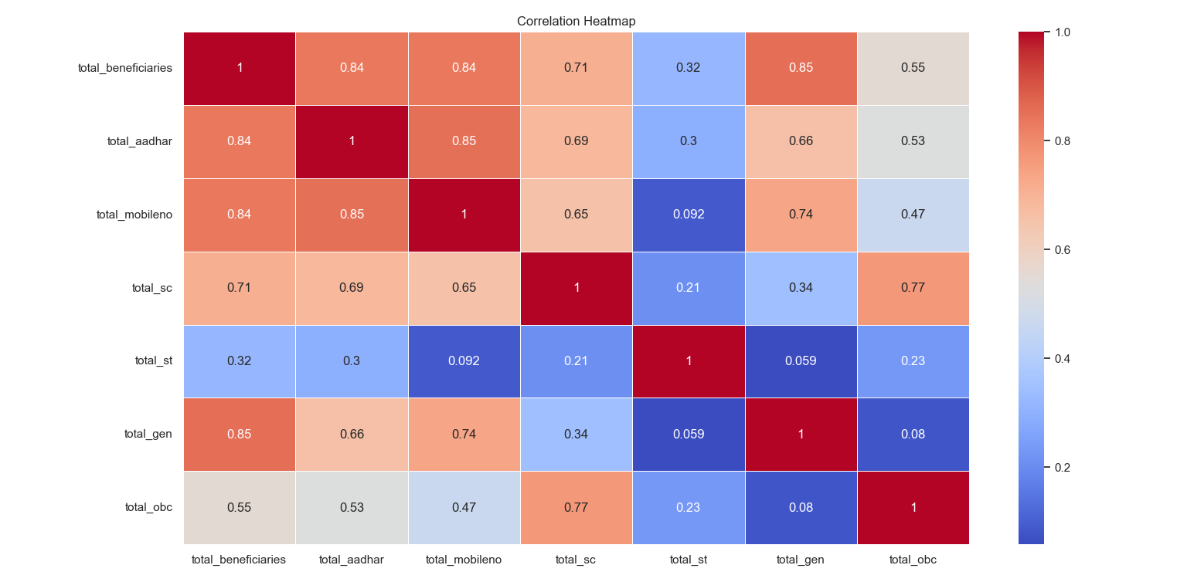

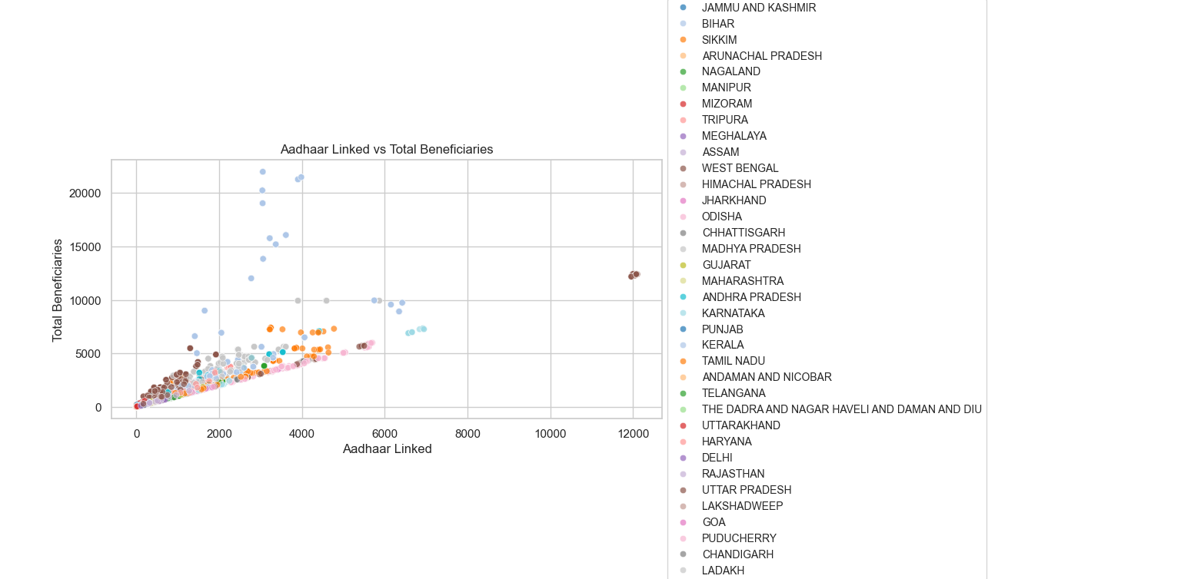

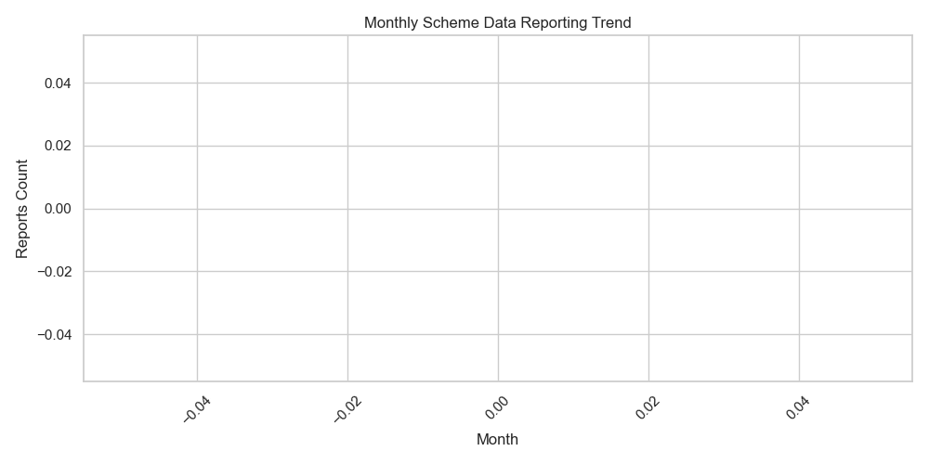

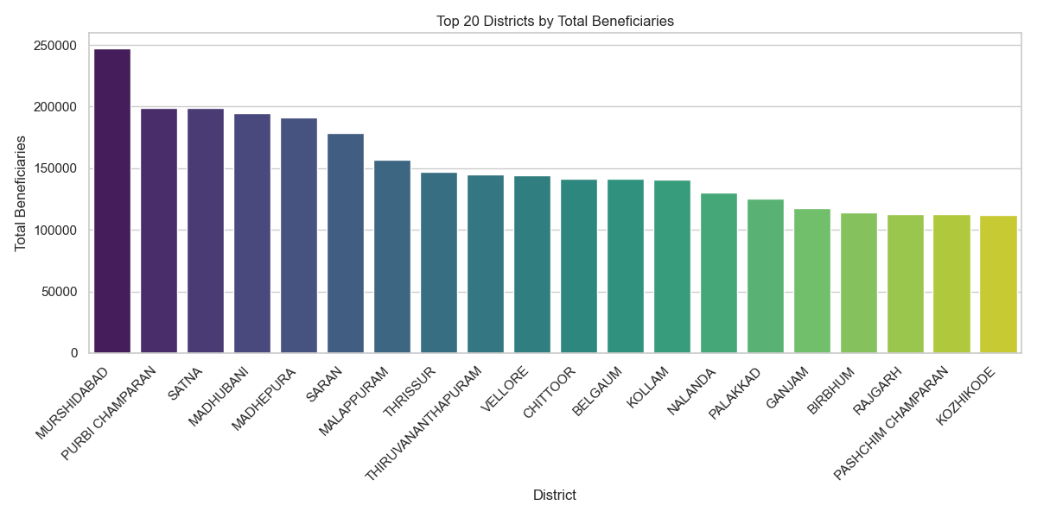

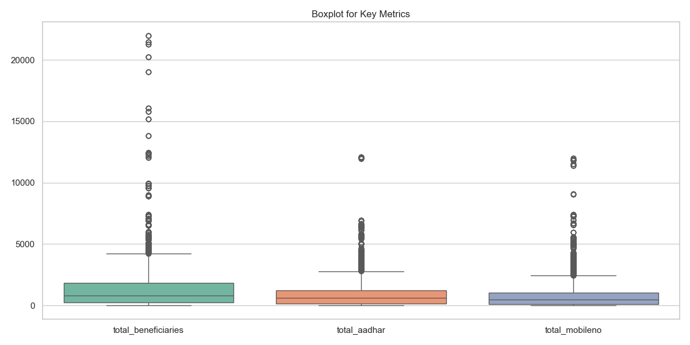

Missing values per column:

fin_year 0

mnth 0

lgd_state_code 0

state_name 0

lgd_district_code 0

district_name 0

scheme_code 0

total_beneficiaries 0

total_sc 0

total_st 0

total_gen 0

total_obc 0

total_aadhar 0

total_mobileno 0

lastUpdated 0

dtype: int64

Correlation between Total Aadhar and Total Beneficiaries: 0.8359695973539879

Top 5 Districts by Inclusion Score:

district_name inclusion_score

466 NEW DELHI 0.999143

643 TAPI 0.997176

684 VALSAD 0.994914

146 DANG 0.993853

477 NORTH WEST- I 0.992968

Top 5 States by Inclusion Score:

state_name inclusion_score

7 DELHI 0.986018

30 TELANGANA 0.918032

35 WEST BENGAL 0.911258

0 ANDAMAN AND NICOBAR 0.889147

29 TAMIL NADU 0.872944